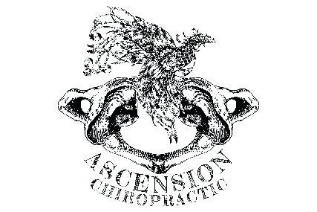

Personal Injury Questionnaire

Name: Phone:
Address: City: State: Zip:

Age:
Birth Date:
Sex: M F SSN:

Employer’s Name: Employer’s Address: Auto Insurance Company: I Policy #: Agent’s Name: Address: City: State: Zip: Name on Policy (if other than Responsible Party’s Name: Address: City: State: Zip:

Attorney
Name: Phone: Address: City: State: Zip: Were there any witnesses? YES NO
Name:

Nature of Accident
- Date of accident: Time of day:
- Were you: Driver Passenger Front Seat Back Seat
- Number of people in your vehicle: Were you wearing seat belts? YES NO
- What direction were you headed? North South East West
On (Name of street):
- What direction was the other vehicle headed? North South East West
On (Name of street):
- Were you struck from: Behind Front Left side Right side
- Approximate speed of your vehicle: mph Other car: mph
- Were you knocked unconscious? YES NO
- Were police notified? YES NO
- In your own words, please describe the accident:

- Did you have any physical complaints before the accident? YES NO
If yes, Please describe in detail:
Upper Cervical Chiropractic of Georgia
2055 Hamilton Creek Pkwy., Ste. 102, Dacula, GA 30019 ~ www.GetWellGA.com ~ P: 770I614I9444 F: 770I614I9444
Dr. Ryan Yocum – Ascension Chiropractic, LLC.
214 S. Sunrise Dr. Raymore, MO. 64083

12. Please describe how you felt:
Personal Injury Questionnaire

- During the accident:
- Immediately after the accident:
- Later that day:
- The next day: 13: What are your PRESENT complaints and symptoms?

- Do you have any congenital (from birth) factors which relate to this problem? YES NO
- Do you have any previous illnesses which relate to this cause? YES NO
If yes, please describe:
- Have you ever been involved in an accident before? YES NO
If yes, please describe, including date(s), type(s) of accidents, as well as injury(ies) received:

- Where were you taken after the accident?
- Have you been treated by another doctor since the accident? YES NO
If yes, please list the doctor’s name and address:

- Since the injury occurred, are your symptoms: Improving Getting Worse Same
- Check the symptoms you have noticed since the accident:
Headache Head Seems Too Heavy Loss of Smell
Back Pain Numbness in Fingers Constipation
Chest Pain Shortness of Breath Lights Bother Eyes
Pins and Needles in Arms Loss of Memory Buzzing in Ears
Hands Cold Loss of Balance Loss of Taste
Neck Pain Diarrhea Fever
Nervousness Sleeping Problems Fatigue
Dizziness Irritability Ears Ring
Pins and Needles in Legs Cold Sweats Fainting
Numbness in Toes Feet Cold Stomach Upset
Neck Stiff Depression
Tension Face Flushed
Other Symptoms Other Than Above:

- Have you lost time from work as a result of this accident? YES NO
If yes, when was the last day worked:
- Do you notice any activity restrictions as a result of this injury? YES NO
If yes, please describe in detail:

Patient Signature Date Date

Dr. Ryan Yocum, Ascension Chiropractic, LLC.
214 S. Sunrise Dr. Raymore, MO. 64083

